Mohammad Farhan Aziz Najeeb

hw - 4

FLOW OVER 2D-CYLINDER

2d LAMINAR AND INVISCID FLOW

AEE 558 - CFD

**TABLE OF CONTENTS**

1. INTRODUCTION
2. 2D LAMINAR FLOW OVER A CYLINDER
3. 2D INVISCID FLOW OVER A CYLINDER
4. References

**INTRODUCTION**

In spite of extensive experimental and numerical studies almost over a century, flow around a circular cylinder still remains a challenging problem in fluid mechanics, where intensive investigations are continued even today to understand the complex unsteady dynamics of the cylinder wake flow. Both experimental measurements and numerical computations have confirmed the onset of instability of the wake flow behind a cylinder beyond a critical Reynolds number, leading finally to a kind of periodic flow identified by definite frequencies, well-known in the literature as the Von Karman vortex street. In case of laminar flow past cylinders with regular polygonal cross-section, the flow usually separates at one or more sharp corners of the cross-section geometry itself, forming a system of vortices in the wake on either side of the mid symmetry plane. On the other hand, for a circular cylinder, where the point of flow separation is decided by the nature of the upstream boundary layer, the physics of the flow is much more complex than what its relatively simple shape might suggest.

As the flow Reynolds number (Re=UD/ν) based on the free stream velocity (U), cylinder diameter (D) and kinematic viscosity ν of the fluid, changes from a creeping laminar flow to a turbulent flow of the Re of a million or even higher, variety of physical complexities start taking place. Steady laminar flow exists at Reynolds number between 5 and 40 with a pair of symmetric counter-rotating vortices formed behind the cylinder. Beyond a critical value of Re, depending on the other flow disturbances, a transverse oscillation sets in with loss of flow symmetry and vortices are shed from the cylinder surface. Between Re=190 and 260, wakes of 2D cylinders are observed to become susceptible to a primary instability mechanism which leads to the amplification of 3D disturbances and eventually to the development of strong streamwise oriented vortical structures. These three-dimensional disturbances alter the structure and evolution of the wake vortices and as a result, even at low Reynolds number, two-dimensional simulations often fail to accurately predict even gross flow quantities.

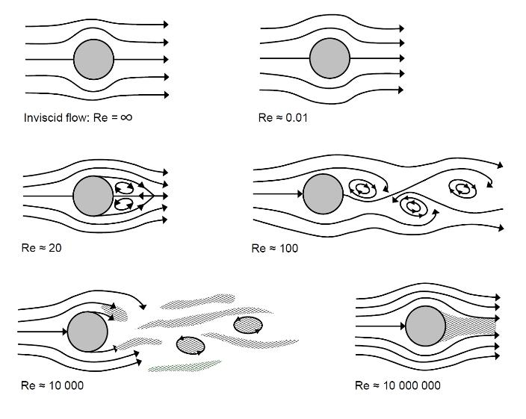

Figure 1 FLOW OVER A 2D CYLINDER

In this Project we consider a 2D inviscid and 2D laminar flow around a cylinder with radius Rcyl =0.5m and a far-field boundary at a radius of Rmax =10m. Using Cradle CFD we describe a 2D inviscid and 2D laminar flow over the 2D cylinder.

**Laminar Flow**

Using Reynolds number Re = $\frac{ρU∞2Rcyl}{ µ}$ = 40 so that the flow is laminar and steady (where = 1 kg/m3 and µ = 0.025 Ns/m2 yielding U∞ = 1 m/s). Creating an appropriate mesh to show the plot of the convergence history, the Cp distribution in the entire domain. The predicted and calculated drag coefficient Cd = $\frac{2FD}{ρU∞2Rcyl}$ = 2FD at this Reynolds number is shown and the given experimental value is about 1.8. A grid convergence study for Cd with at least three different mesh resolutions and the continuum value is also calculated.

Since the drag force is broken down into pressure and viscous component, we calculate the pressure and viscous force on the surface of the cylinder.

While creating the mesh we concentrate the mesh refinement over the cylinder as to get a much accurate result.

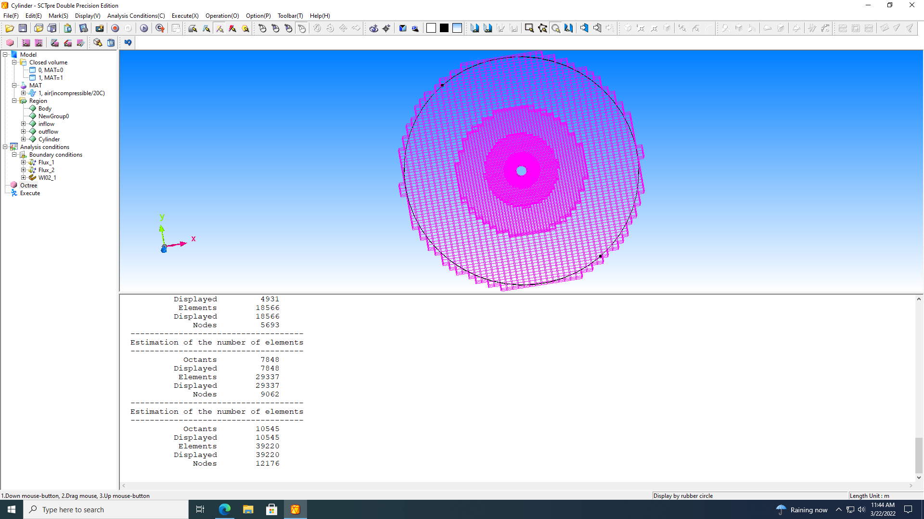 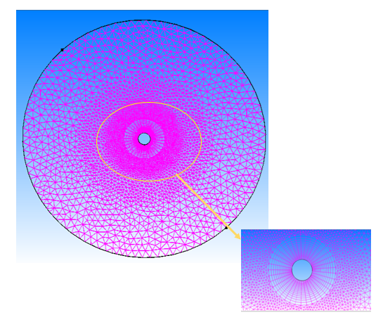

Figure 2 Mesh before Refinement Figure 3 Mesh after refinement

The Total drag force Cd =(Fp +Fv)*10*2; we are multiplying by 10 to convert the result because we get the result in terms of N/0.1ms2.

The calculated values for three different mesh resolutions are shown below in the table.

|  |  |  |  |  |
| --- | --- | --- | --- | --- |
| **SL no.** | **No. of Nodes** | **Cd** | **Pressure** | **Viscous** |
| 1 | 0.0001459 | 1.666416 | 0.055462 | 0.027859 |
| 2 | 0.000143885 | 1.66566 | 0.055408 | 0.027875 |
| 3 | 0.000136351 | 1.664402 | 0.055301 | 0.027919 |

Since we do not have the exact error values we use N-p/d for nodes in our grid convergence study, where cradle is second order so p=2 and the dimension d=2.

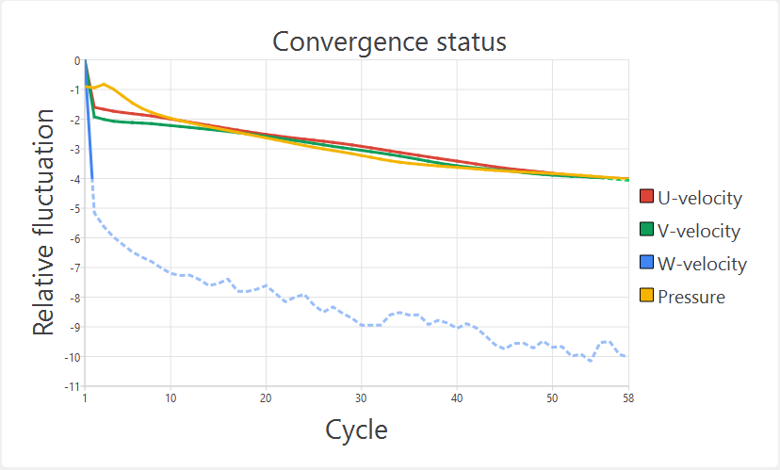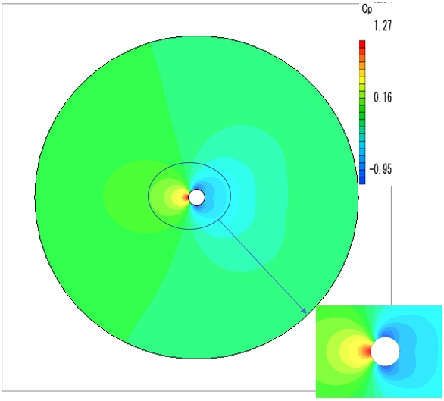

Figure 4 Convergence history Figure 5 Cp distribution

The result converges in 58 cycles and in figure 6 we can see that the streamlines formed by the laminar flow behind the cylinder is turbulent and in front of the cylinder is the stagnation point.

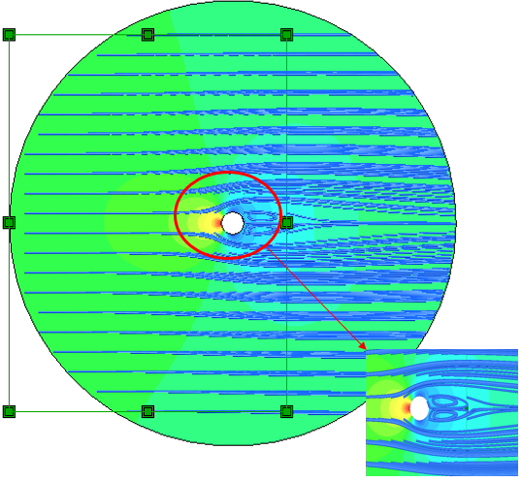 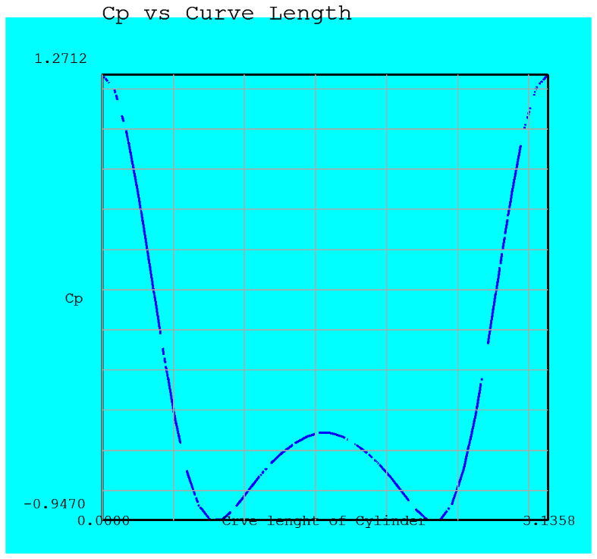

Figure 6 Streamlines of Flow Figure 7 Cp vs Curve length of the cylinder

*The pressure forces are 2/3 times and the viscous forces are 1/3 times the drag force.*

Below shown is the grid convergence study for three mesh resolutions and the continuum value can be found by extrapolating the line towards the y intercept.

The continuum value is approximately 1.664.

Figure 8 Grid convergence study

**Inviscid Flow**

A free-stream velocity of U∞ = 1 m/s is considered over the cylinder.

A plot of the convergence history as well as the Cp distribution in the entire domain is shown. Finally, Cp vs. the curve length of the cylinder surface is shown in fig 11 and to compare with the potential flow theory prediction we use the equation of Cexpsurf =1-4sin2 θ.

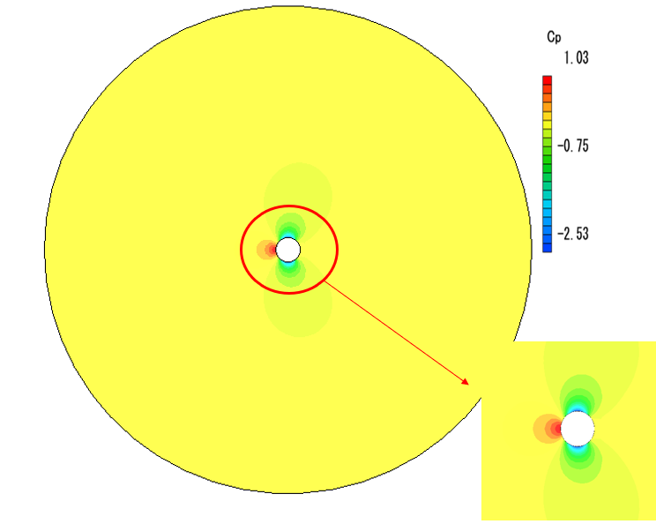 Figure 9 Cp distribution over cylinder

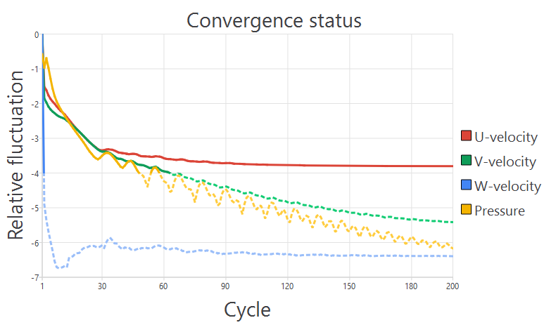

Figure 10 convergence history

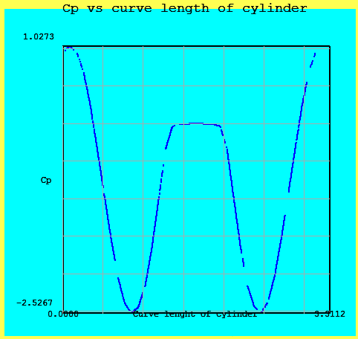

Figure 11 Cp vs curve length of cylinder

The result shown while comparing the computed and the analytical values are approximately similar to that of the exact solution of Cp.

**References**

# B.N.Rajani, A. Kandasamy, S.Majumdar “Numerical simulation of laminar flow past a circular cylinder,” Applied Math Modelling, vol.33(3), pp 1228-1247, March 2009.

# Google Image: https://www.google.com/url?sa=i&url=https%3A%2F%2Fcfdflowengineering.com%2Fcfd-modeling-of-flow-over-a-cylinder%2F&psig=AOvVaw0y3OV0BAWKGRCvZRSoj3La&ust=1648068993151000&source=images&cd=vfe&ved=0CAsQjRxqFwoTCJDukcrN2vYCFQAAAAAdAAAAABAD